EARA group visit to Nightingale Primary School
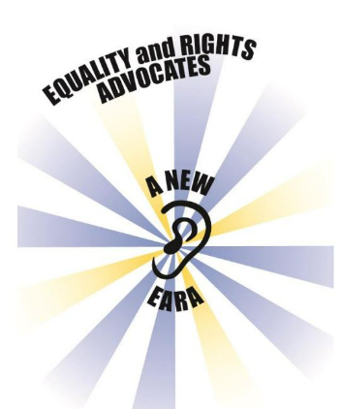

Year 2 EARA representatives: Eliza, Harry, Bea, Oakley, Zephy and Rosie N.
Our Year 2 EARA children went to Nightingale Primary School on Tuesday morning, to join with other EARA groups in the Eastleigh and Winchester area. Miss Read and myself took them, and were very proud of their great listening, sensible behaviour and eager participation.
There were EARA groups from 6 other schools, and the others were all Juniors, with only us Infants! The symbol of EARA groups has an ear in the middle, and Eliza put up her hand to suggest it is because EARA groups listen to people. Zephy described the rays around the ear as the sounds people can hear when they want to talk.
The children listened to Minnie talk about equality and stereotypes (Minnie Moore is the County Inclusion and Diversity lead, who has recently done some work with our Governing Body, and who leads and supports pupil voice and EARA in Hampshire).
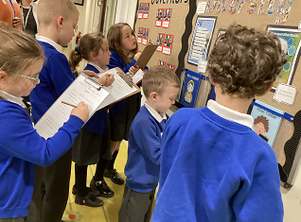 We found out facts about famous people who are diverse – Greta Thunberg who is autistic and Albert Einstein who is dyslexic.

We discussed challenging stereotypes:
In a scenario where Melissa wanted to play football at playtime but the boys wouldn’t let her because she was a girl and girls don’t play football… Bea said ‘boys and girls can play football. I like football’.
Finally, some schools shared some of the work from their EARA meetings. Our children stood up the front of Nightingale School hall and spoke a few lines that we had rehearsed, all about what EARA means and how we want things to be fair for all children.


